Boolean Algebra

There are three Boolean operations that are common in assembler programs.

AND

When we AND two bits, the result is one if and only if both original bits are one.

We can create a truth table and K-map that looks like this:

A B X
0 0 | 0
0 1 | 0
1 0 | 0
1 1 | 1
 | 0 | 1
0 | 0 | 0
1 | 0 | 1

AND is most often used to mask bits in a word.

Example:

Given the 8 bits 0 0 1 1 0 1 0 1 ( 35h)

if we want to only use the low order bits for some reason, we can mask out the high order bits by ANDing this byte with the byte 0 0 0 0 1 1 1 1 (0Fh). As shown in the truth table, wherever there is a one in the mask, that bit comes through in the result. Where there is a zero, the bit is masked out.

AND is also used to test the value of a single bit.

Example:

Given the 8 bits 0 0 1 1 1 0 0 0 (38h)

if we want to test bit 2, we create the mask 0 0 0 0 0 1 0 0 (04h). ANDing the original byte with the mask we get 0 0 0 0 0 0 0 0.

Since the result is zero, the bit we let pass through the mask must also be zero. If we had used the mask 0 0 0 0 1 0 0 0 (08h) we would have gotten 0 0 0 0 1 0 0 0 - - the one passed through.

OR

When we OR two bits, the result is zero if and only if both original bits are zero. Another way of saying this is that the result is one if either or both of the original bits are one.

We can create a truth table and k-map that looks like this:

A B X
0 0 | 0
0 1 | 1
1 0 | 1
1 1 | 1

 | 0 | 1
0 | 0 | 1
1 | 1 | 1

OR is often used to set one bit in a byte to a one without changing any of the others.

Example:

Given the byte 0 0 1 1 0 0 0 1 (31h)

to set the high order bit to a one, without affecting any of the other bits, we simply OR the byte with the byte 1 0 0 0 0 0 0 0. As you can see from the truth table, the one in the high order position of the mask always results in the high order bit of the original byte being set to one.

XOR

When we XOR two bits, the result is one if and only if one of the original bits is one, but not both.

We can create a truth table and k-map that looks like this:

A B X
0 0 | 0
0 1 | 1
1 0 | 1
1 1 | 0

 | 0 | 1
0 | 0 | 1
1 | 1 | 0

One of the important properties of XOR is that we can toggle individual bits in a byte without having to know beforehand what the value of the original bit was.

Example:

Given the original value 1 0 1 0 0 0 1 0
and the XOR mask 1 1 1 0 1 0 1 1

the result is 0 1 0 0 1 0 0 1

If we use the same mask again on the result we get

result value 0 1 0 0 1 0 0 1
XOR mask 1 1 1 0 1 0 1 1

the result is 1 0 1 0 0 0 1 0 The original value!

What happens if you XOR a value with itself? Try it …

1 0 0 1 1 0 0 0
1 0 0 1 1 0 0 0

0 0 0 0 0 0 0 0

The result is always zero. This trick is often used to set a byte to zero, because it is very fast.

Digital Circuits

Digital computers are constructed from simple digital circuits called gates. The term gates come from their ability to open or close pathways for electrical signals. For now, consider these gates as black boxes. The figure below represents such a black box.
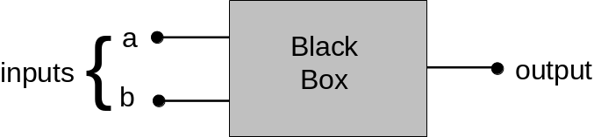

Limiting us to the binary number system, there are two possible states for each input, ZERO and ONE and similarly two possible states for the output. We can design a black box so that each particular combination of inputs always produces the same output. For example we could define a black box that outputs a one only when just one of the inputs is a one. We write this in a truth table:

Input Output
a b

0 0 0
0 1 1
1 0 1
1 1 0

Clearly we could define black boxes that produced different outputs for the same combination of inputs. In fact, with two inputs we can define 16 black boxes.

Input Black Boxes
a | b | 0 | 1 | 2 | 3 | 4 | 5 | 6 | 7 | 8 | 9 | 10 | 11 | 12 | 13 | 14 | 15
0 | 0 | 0 | 1 | 0 | 1 | 0 | 1 | 0 | 1 | 0 | 1 | 0 | 1 | 0 | 1 | 0 | 1
0 | 1 | 0 | 0 | 1 | 1 | 0 | 0 | 1 | 1 | 0 | 0 | 1 | 1 | 0 | 0 | 1 | 1
1 | 0 | 0 | 0 | 0 | 0 | 1 | 1 | 1 | 1 | 0 | 0 | 0 | 0 | 1 | 1 | 1 | 1
1 | 1 | 0 | 0 | 0 | 0 | 0 | 0 | 0 | 0 | 1 | 1 | 1 | 1 | 1 | 1 | 1 | 1

Let’s look at these in more detail. Box zero always outputs a 0 no matter what the inputs are, so it is not of much use. Similarly box 15 always produces a one, no matter what the inputs are. Boxes 3 and 12 produce the same output no matter what input b is and boxes 5 and 10 produce the same output no matter what a is. For these boxes we might just as well disconnect the input that does not affect the output. This is illustrated in the figure below:

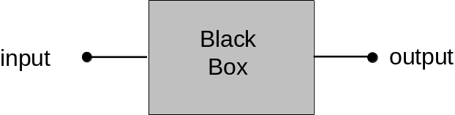
In this case there are four possible boxes that can be created.

Black Boxes
Input | 0 | 1 | 2 | 3
0 | 0 | 1 | 0 | 1
1 | 0 | 0 | 1 | 1

Boxes 0 and 3 are not interesting because the input does not affect the output. Box 2 can be replaced with a single wire that simply connects the input to the output. This leaves box 1 as the only interesting case. It inverts or complements the input signal, changing ONE’s to ZERO’s and ZERO’s to ONE’s. It is called an inverter or NOT circuit. In a circuit diagram a NOT is usually shown as a small open circle as shown below.

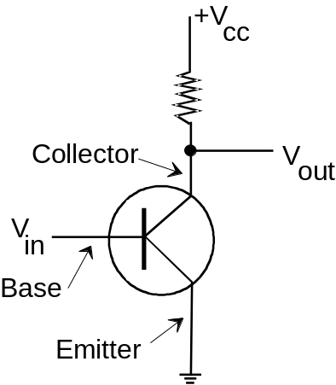We can now peek inside this black box to see how the circuit works. All modern digital computers depend on the fact that a transistor can be made to operate as a very fast digital switch. In the diagram below we have a transistor embedded in a simple digital circuit. The transistor has three connections to the outside world, the collector, the emitter, and the base. When the input voltage, V_{in,} is below a certain critical level the transistor turns off and acts like an infinite resistance. This causes the output of the circuit, V_{out}, to take on a value close to V_{cc}, an externally regulated voltage – typically 3-5 volts. When V_{in} exceeds the critical voltage, the transistor turns on and conducts current as if it were a straight wire, causing V_{out} to be pulled to ground or zero volts. The important thing to note is that when V_{in} is high, V_{out} is low, and vice-versa. Thus the circuit inverts the signal at Vin. A high voltage, in the range of 3-5 volts is considered to be a binary one. A low voltage is considered to be a binary zero.

Returning to the table of sixteen black boxes, look at box 8. It produces a ONE if and only if both input a and input b are ONE. It is called an AND gate and is drawn as shown below:
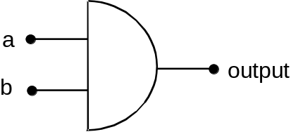

Combining an AND and a NOT we get box 7 which is called a NAND gate.

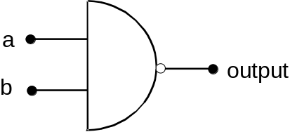
Another interesting black box is box 14. It is called an inclusive OR (or more commonly just OR) gate since the output is ONE if either or both inputs are ONE. Box 1 is a NOR gate. Compare box 14 with Box 6 is which is an exclusive OR, the output being ONE only if one input to the other is ONE, but not both.

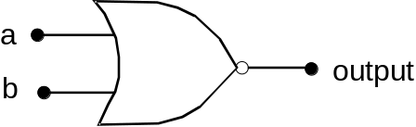 A NOR gate

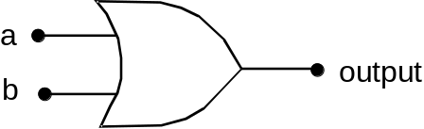
An OR gate

NOT, AND, NAND, OR, and NOR gates form the basis for all other digital circuits. NAND and NOR gates are used more often than AND and OR because they require fewer transistors to build. Gates can be combined to form more complex circuits. In addition, gates can have more than two inputs. For example, the following diagram is an AND circuit built from NOR gates.
